Path Analysis:

Standardized Solution:

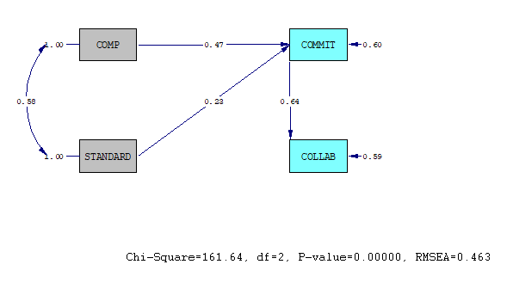

T-Values:

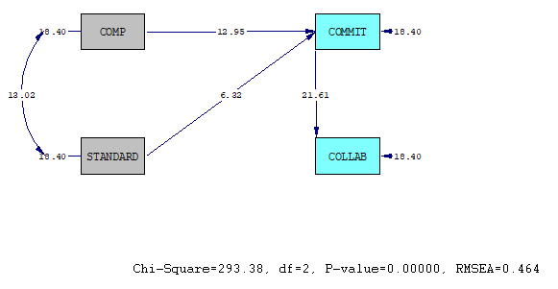

Regression using Survey Data

Number of Iterations = 6

LISREL Estimates (Maximum Likelihood)

Structural Equations

COMMIT = 0.472*COMP + 0.230*STANDARD, Errorvar.= 0.599 , R² = 0.401

Standerr (0.0365) (0.0365) (0.0326)

Z-values 12.931 6.308 18.371

P-values 0.000 0.000 0.000

COLLAB = 0.639*COMMIT, Errorvar.= 0.592 , R² = 0.408

Standerr (0.0296) (0.0322)

Z-values 21.583 18.371

P-values 0.000 0.000

NOTE: R² for Structural Equations are Hayduk's (2006) Blocked-Error R²

Reduced Form Equations

COMMIT = 0.472*COMP + 0.230*STANDARD, Errorvar.= 0.599, R² = 0.401

Standerr (0.0365) (0.0365)

Z-values 12.922 6.304

P-values 0.000 0.000

COLLAB = 0.302*COMP + 0.147*STANDARD, Errorvar.= 0.836, R² = 0.164

Standerr (0.0272) (0.0243)

Z-values 11.084 6.051

P-values 0.000 0.000

Correlation Matrix of Independent Variables

COMP STANDARD

-------- --------

COMP 1.000

(0.054)

18.371

STANDARD 0.578 1.000

(0.044) (0.054)

13.001 18.371

Covariance Matrix of Latent Variables

COMMIT COLLAB COMP STANDARD

-------- -------- -------- --------

COMMIT 1.000

COLLAB 0.639 1.000

COMP 0.605 0.387 1.000

STANDARD 0.503 0.321 0.578 1.000

Log-likelihood Values

Estimated Model Saturated Model

--------------- ---------------

Number of free parameters(t) 8 10

-2ln(L) 1730.133 1436.753

AIC (Akaike, 1974)* 1746.133 1456.753

BIC (Schwarz, 1978)* 1782.274 1501.930

*LISREL uses AIC= 2t - 2ln(L) and BIC = tln(N)- 2ln(L)

Goodness-of-Fit Statistics

Degrees of Freedom for (C1)-(C2) 2

Maximum Likelihood Ratio Chi-Square (C1) 293.380 (P = 0.0000)

Browne's (1984) ADF Chi-Square (C2_NT) 238.080 (P = 0.0000)

Estimated Non-centrality Parameter (NCP) 291.380

90 Percent Confidence Interval for NCP (238.782 ; 351.385)

Minimum Fit Function Value 0.433

Population Discrepancy Function Value (F0) 0.430

90 Percent Confidence Interval for F0 (0.353 ; 0.519)

Root Mean Square Error of Approximation (RMSEA) 0.464

90 Percent Confidence Interval for RMSEA (0.420 ; 0.509)

P-Value for Test of Close Fit (RMSEA < 0.05) 0.000

Expected Cross-Validation Index (ECVI) 0.457

90 Percent Confidence Interval for ECVI (0.379 ; 0.546)

ECVI for Saturated Model 0.0295

ECVI for Independence Model 1.890

Chi-Square for Independence Model (6 df) 1271.247

Normed Fit Index (NFI) 0.769

Non-Normed Fit Index (NNFI) 0.309

Parsimony Normed Fit Index (PNFI) 0.256

Comparative Fit Index (CFI) 0.770

Incremental Fit Index (IFI) 0.770

Relative Fit Index (RFI) 0.308

Critical N (CN) 22.224

Root Mean Square Residual (RMR) 0.136

Standardized RMR 0.136

Goodness of Fit Index (GFI) 0.850

Adjusted Goodness of Fit Index (AGFI) 0.252

Parsimony Goodness of Fit Index (PGFI) 0.170

Confirmatory Factor Analysis:

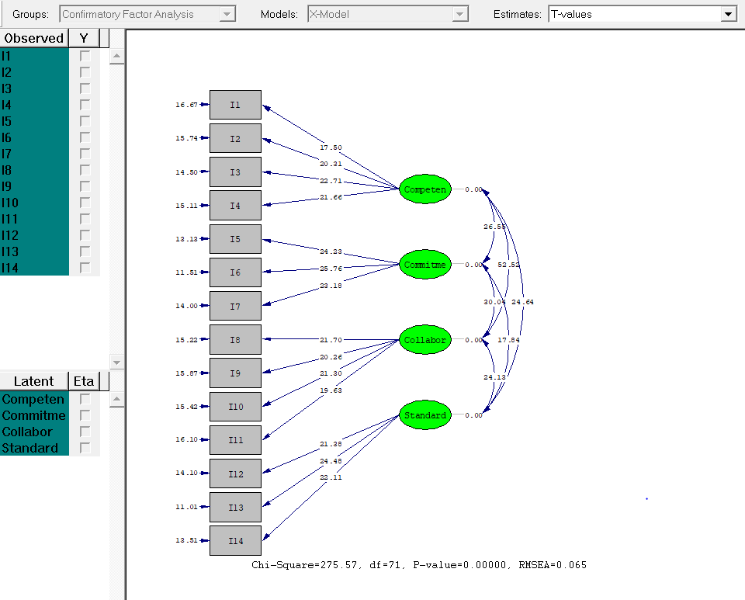

Confirmatory Factor Analysis

Number of Iterations = 6

LISREL Estimates (Maximum Likelihood)

Measurement Equations

I1 = 0.636*Competen, Errorvar.= 0.596 , R² = 0.404

Standerr (0.0364) (0.0358)

Z-values 17.487 16.661

P-values 0.000 0.000

I2 = 0.713*Competen, Errorvar.= 0.492 , R² = 0.508

Standerr (0.0351) (0.0313)

Z-values 20.292 15.727

P-values 0.000 0.000

I3 = 0.773*Competen, Errorvar.= 0.403 , R² = 0.597

Standerr (0.0341) (0.0278)

Z-values 22.689 14.491

P-values 0.000 0.000

I4 = 0.747*Competen, Errorvar.= 0.442 , R² = 0.558

Standerr (0.0345) (0.0293)

Z-values 21.644 15.099

P-values 0.000 0.000

I5 = 0.811*Commitme, Errorvar.= 0.343 , R² = 0.657

Standerr (0.0335) (0.0261)

Z-values 24.211 13.122

P-values 0.000 0.000

I6 = 0.846*Commitme, Errorvar.= 0.284 , R² = 0.716

Standerr (0.0329) (0.0247)

Z-values 25.740 11.504

P-values 0.000 0.000

I7 = 0.786*Commitme, Errorvar.= 0.383 , R² = 0.617

Standerr (0.0339) (0.0273)

Z-values 23.167 13.994

P-values 0.000 0.000

I8 = 0.747*Collabor, Errorvar.= 0.442 , R² = 0.558

Standerr (0.0344) (0.0291)

Z-values 21.681 15.211

P-values 0.000 0.000

I9 = 0.710*Collabor, Errorvar.= 0.496 , R² = 0.504

Standerr (0.0351) (0.0313)

Z-values 20.242 15.856

P-values 0.000 0.000

I10 = 0.737*Collabor, Errorvar.= 0.457 , R² = 0.543

Standerr (0.0346) (0.0297)

Z-values 21.288 15.404

P-values 0.000 0.000

I11 = 0.693*Collabor, Errorvar.= 0.519 , R² = 0.481

Standerr (0.0354) (0.0323)

Z-values 19.613 16.091

P-values 0.000 0.000

I12 = 0.751*Standard, Errorvar.= 0.436 , R² = 0.564

Standerr (0.0352) (0.0309)

Z-values 21.361 14.089

P-values 0.000 0.000

I13 = 0.831*Standard, Errorvar.= 0.310 , R² = 0.690

Standerr (0.0340) (0.0282)

Z-values 24.460 11.001

P-values 0.000 0.000

I14 = 0.770*Standard, Errorvar.= 0.407 , R² = 0.593

Standerr (0.0349) (0.0301)

Z-values 22.091 13.504

P-values 0.000 0.000

Correlation Matrix of Independent Variables

Competen Commitme Collabor Standard

-------- -------- -------- --------

Competen 1.000

Commitme 0.716 1.000

(0.027)

26.551

Collabor 0.917 0.754 1.000

(0.017) (0.025)

52.523 30.037

Standard 0.702 0.584 0.696 1.000

(0.029) (0.033) (0.029)

24.635 17.840 24.127

Log-likelihood Values

Estimated Model Saturated Model

--------------- ---------------

Number of free parameters(t) 34 105

-2ln(L) 4828.565 4552.999

AIC (Akaike, 1974)* 4896.565 4762.999

BIC (Schwarz, 1978)* 5050.166 5237.354

*LISREL uses AIC= 2t - 2ln(L) and BIC = tln(N)- 2ln(L)

Goodness-of-Fit Statistics

Degrees of Freedom for (C1)-(C2) 71

Maximum Likelihood Ratio Chi-Square (C1) 275.566 (P = 0.0000)

Browne's (1984) ADF Chi-Square (C2_NT) 293.598 (P = 0.0000)

Estimated Non-centrality Parameter (NCP) 204.566

90 Percent Confidence Interval for NCP (157.332 ; 259.374)

Minimum Fit Function Value 0.407

Population Discrepancy Function Value (F0) 0.302

90 Percent Confidence Interval for F0 (0.232 ; 0.383)

Root Mean Square Error of Approximation (RMSEA) 0.0652

90 Percent Confidence Interval for RMSEA (0.0572 ; 0.0735)

P-Value for Test of Close Fit (RMSEA < 0.05) 0.00106

Expected Cross-Validation Index (ECVI) 0.507

90 Percent Confidence Interval for ECVI (0.438 ; 0.588)

ECVI for Saturated Model 0.310

ECVI for Independence Model 7.316

Chi-Square for Independence Model (91 df) 4925.001

Normed Fit Index (NFI) 0.944

Non-Normed Fit Index (NNFI) 0.946

Parsimony Normed Fit Index (PNFI) 0.737

Comparative Fit Index (CFI) 0.958

Incremental Fit Index (IFI) 0.958

Relative Fit Index (RFI) 0.928

Critical N (CN) 250.301

Root Mean Square Residual (RMR) 0.0409

Standardized RMR 0.0409

Goodness of Fit Index (GFI) 0.942

Adjusted Goodness of Fit Index (AGFI) 0.914

Parsimony Goodness of Fit Index (PGFI) 0.637

Confirmatory Factor Analysis

Qplot of Standardized Residuals

3.5..........................................................................

. ..

. . .

. . .

. . .

. . .

. . .

. . .

. . x

. . .

. . x .

. . x .

. . x .

. . xx .

. . x x .

N . . x .

o . . xxx x .

r . .** .

m . .*x .

a . .xxx .

l . x.* .

. x*.* .

Q . x* .

u . x* .

a . *x .

n . *x .

t . **x .

i . *x. .

l . **. .

e . x *x. .

s . x * . .

. * . .

. * . .

. x . .

. x . .

. x . .

. . .

. x . .

. . .

. . .

. . .

. . .

. . .

. . .

-3.5..........................................................................

-3.5 3.5

Standardized Residuals

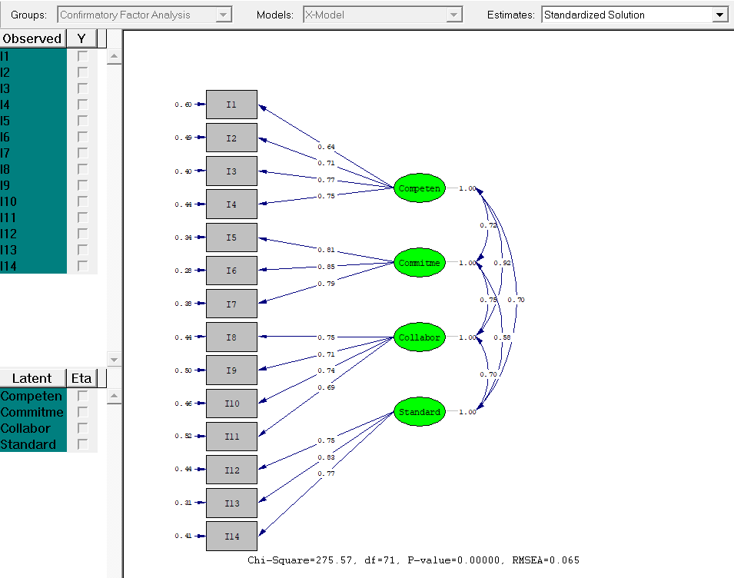

Structural Equation Modeling

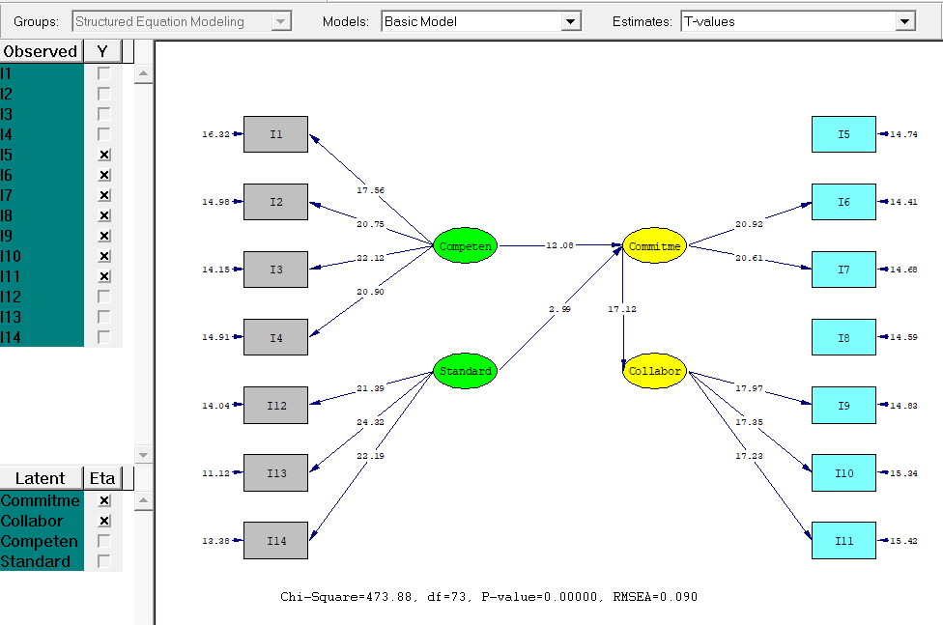

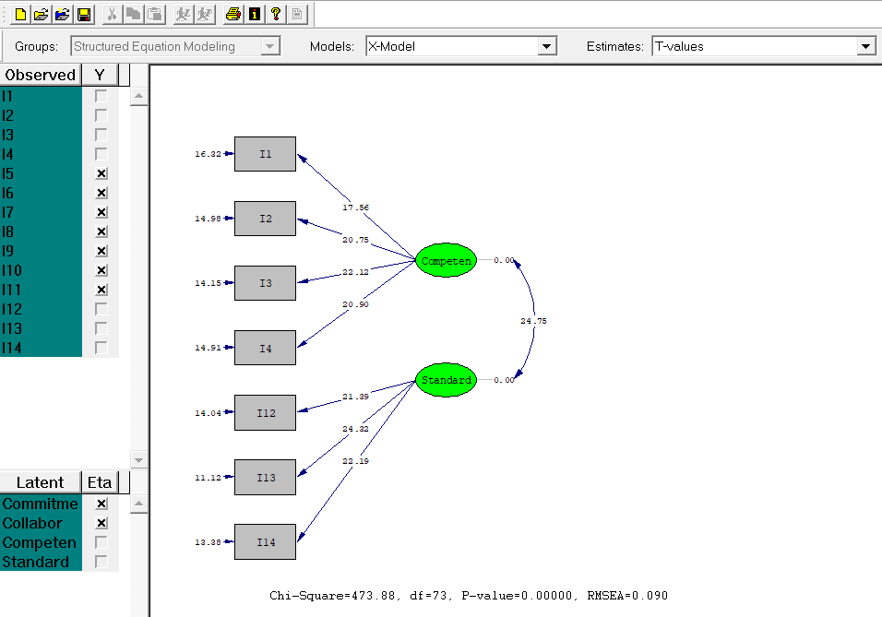

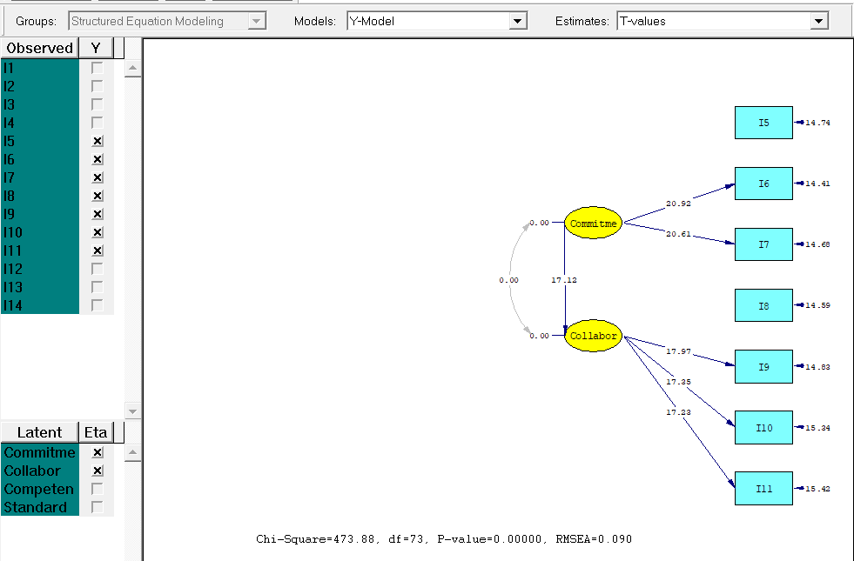

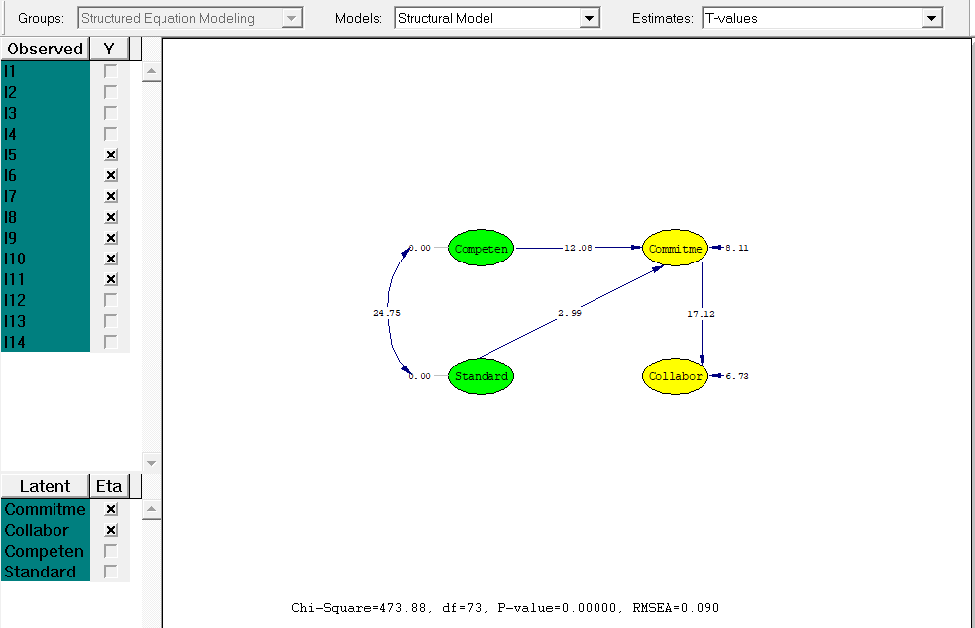

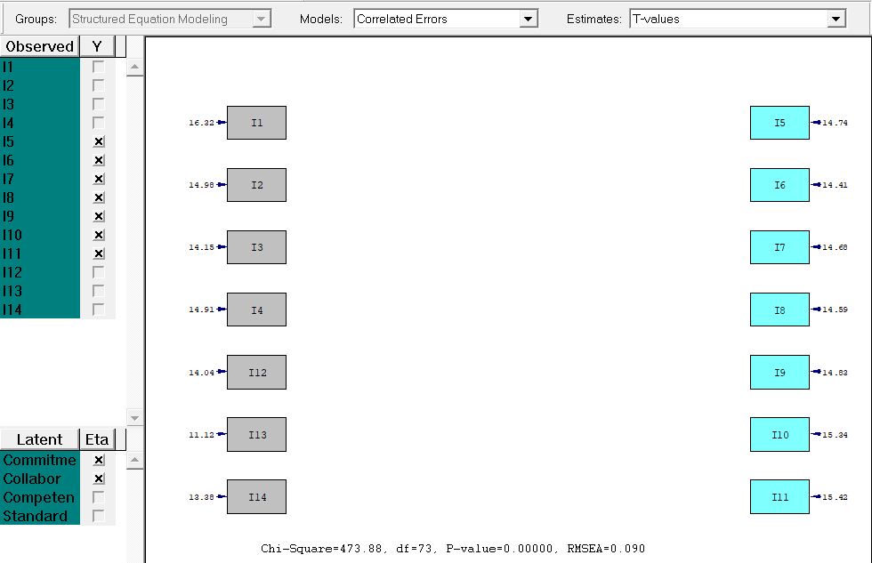

Structured Equation Modeling

Number of Iterations = 15

LISREL Estimates (Maximum Likelihood)

Measurement Equations

I5 = 0.775*Commitme, Errorvar.= 0.399 , R² = 0.601

Standerr (0.0271)

Z-values 14.733

P-values 0.000

I6 = 0.788*Commitme, Errorvar.= 0.378 , R² = 0.622

Standerr (0.0377) (0.0263)

Z-values 20.902 14.396

P-values 0.000 0.000

I7 = 0.778*Commitme, Errorvar.= 0.395 , R² = 0.605

Standerr (0.0378) (0.0269)

Z-values 20.597 14.665

P-values 0.000 0.000

I8 = 0.745*Collabor, Errorvar.= 0.445 , R² = 0.555

Standerr (0.0305)

Z-values 14.579

P-values 0.000

I9 = 0.734*Collabor, Errorvar.= 0.461 , R² = 0.539

Standerr (0.0409) (0.0311)

Z-values 17.956 14.824

P-values 0.000 0.000

I10 = 0.708*Collabor, Errorvar.= 0.498 , R² = 0.502

Standerr (0.0409) (0.0325)

Z-values 17.338 15.326

P-values 0.000 0.000

I11 = 0.704*Collabor, Errorvar.= 0.505 , R² = 0.495

Standerr (0.0409) (0.0328)

Z-values 17.222 15.409

P-values 0.000 0.000

I1 = 0.643*Competen, Errorvar.= 0.587 , R² = 0.413

Standerr (0.0366) (0.0360)

Z-values 17.549 16.304

P-values 0.000 0.000

I2 = 0.730*Competen, Errorvar.= 0.467 , R² = 0.533

Standerr (0.0352) (0.0312)

Z-values 20.736 14.974

P-values 0.000 0.000

I3 = 0.765*Competen, Errorvar.= 0.415 , R² = 0.585

Standerr (0.0346) (0.0294)

Z-values 22.104 14.144

P-values 0.000 0.000

I4 = 0.734*Competen, Errorvar.= 0.462 , R² = 0.538

Standerr (0.0351) (0.0310)

Z-values 20.881 14.895

P-values 0.000 0.000

I12 = 0.752*Standard, Errorvar.= 0.434 , R² = 0.566

Standerr (0.0352) (0.0310)

Z-values 21.378 14.026

P-values 0.000 0.000

I13 = 0.827*Standard, Errorvar.= 0.315 , R² = 0.685

Standerr (0.0341) (0.0284)

Z-values 24.297 11.116

P-values 0.000 0.000

I14 = 0.773*Standard, Errorvar.= 0.402 , R² = 0.598

Standerr (0.0349) (0.0301)

Z-values 22.176 13.370

P-values 0.000 0.000

Structural Equations

Commitme = 0.717*Competen + 0.161*Standard, Errorvar.= 0.298 , R² = 0.702

Standerr (0.0593) (0.0538) (0.0368)

Z-values 12.081 2.989 8.110

P-values 0.000 0.003 0.000

Collabor = 0.864*Commitme, Errorvar.= 0.253 , R² = 0.747

Standerr (0.0505) (0.0376)

Z-values 17.121 6.727

P-values 0.000 0.000

NOTE: R² for Structural Equations are Hayduk's (2006) Blocked-Error R²

Reduced Form Equations

Commitme = 0.717*Competen + 0.161*Standard, Errorvar.= 0.298, R² = 0.702

Standerr (0.0594) (0.0538)

Z-values 12.072 2.987

P-values 0.000 0.003

Collabor = 0.620*Competen + 0.139*Standard, Errorvar.= 0.476, R² = 0.524

Standerr (0.0551) (0.0467)

Z-values 11.251 2.973

P-values 0.000 0.003

Correlation Matrix of Independent Variables

Competen Standard

-------- --------

Competen 1.000

Standard 0.705 1.000

(0.028)

24.751

Covariance Matrix of Latent Variables

Commitme Collabor Competen Standard

-------- -------- -------- --------

Commitme 1.000

Collabor 0.864 1.000

Competen 0.830 0.717 1.000

Standard 0.666 0.575 0.705 1.000

Log-likelihood Values

Estimated Model Saturated Model

--------------- ---------------

Number of free parameters(t) 32 105

-2ln(L) 5026.881 4552.999

AIC (Akaike, 1974)* 5090.881 4762.999

BIC (Schwarz, 1978)* 5235.446 5237.354

*LISREL uses AIC= 2t - 2ln(L) and BIC = tln(N)- 2ln(L)

Goodness-of-Fit Statistics

Degrees of Freedom for (C1)-(C2) 73

Maximum Likelihood Ratio Chi-Square (C1) 473.882 (P = 0.0000)

Browne's (1984) ADF Chi-Square (C2_NT) 515.402 (P = 0.0000)

Estimated Non-centrality Parameter (NCP) 400.882

90 Percent Confidence Interval for NCP (335.786 ; 473.471)

Minimum Fit Function Value 0.700

Population Discrepancy Function Value (F0) 0.592

90 Percent Confidence Interval for F0 (0.496 ; 0.699)

Root Mean Square Error of Approximation (RMSEA) 0.0901

90 Percent Confidence Interval for RMSEA (0.0824 ; 0.0979)

P-Value for Test of Close Fit (RMSEA < 0.05) 0.000

Expected Cross-Validation Index (ECVI) 0.795

90 Percent Confidence Interval for ECVI (0.698 ; 0.902)

ECVI for Saturated Model 0.310

ECVI for Independence Model 7.316

Chi-Square for Independence Model (91 df) 4925.001

Normed Fit Index (NFI) 0.904

Non-Normed Fit Index (NNFI) 0.897

Parsimony Normed Fit Index (PNFI) 0.725

Comparative Fit Index (CFI) 0.917

Incremental Fit Index (IFI) 0.917

Relative Fit Index (RFI) 0.880

Critical N (CN) 149.373

Root Mean Square Residual (RMR) 0.0647

Standardized RMR 0.0647

Goodness of Fit Index (GFI) 0.902

Adjusted Goodness of Fit Index (AGFI) 0.859

Parsimony Goodness of Fit Index (PGFI) 0.627

Structured Equation Modeling

Qplot of Standardized Residuals

3.5..........................................................................

. ..

. . .

. . .

. . .

. . .

. . .

. . .

. . x

. . .

. . x

. . x

. . x

. . *

. . x

N . . x x x

o . . x x x .

r . . * x* .

m . . x * x .

a . . *xx x .

l . *xxxx .

. .*x .

Q . .xx .

u . **x .

a . xxx .

n . xx* .

t . *x .

i . xx .

l . x*. .

e . x xx . .

s . xxx . .

. x* . .

. x x . .

. x . .

.x . .

x . .

. . .

x . .

. . .

. . .

. . .

. . .

. . .

. . .

-3.5..........................................................................

-3.5 3.5

Standardized Residuals